# **Related Apps Review**

# ../../Desktop/Screen%20Shot%202016-08-30%20at%2010.20.21%20PM.pngWeChat – Communication and real-time location sharing

**Google Play URL**: https://play.google.com/store/apps/details?id=com.tencent.mm

**Screenshots:**

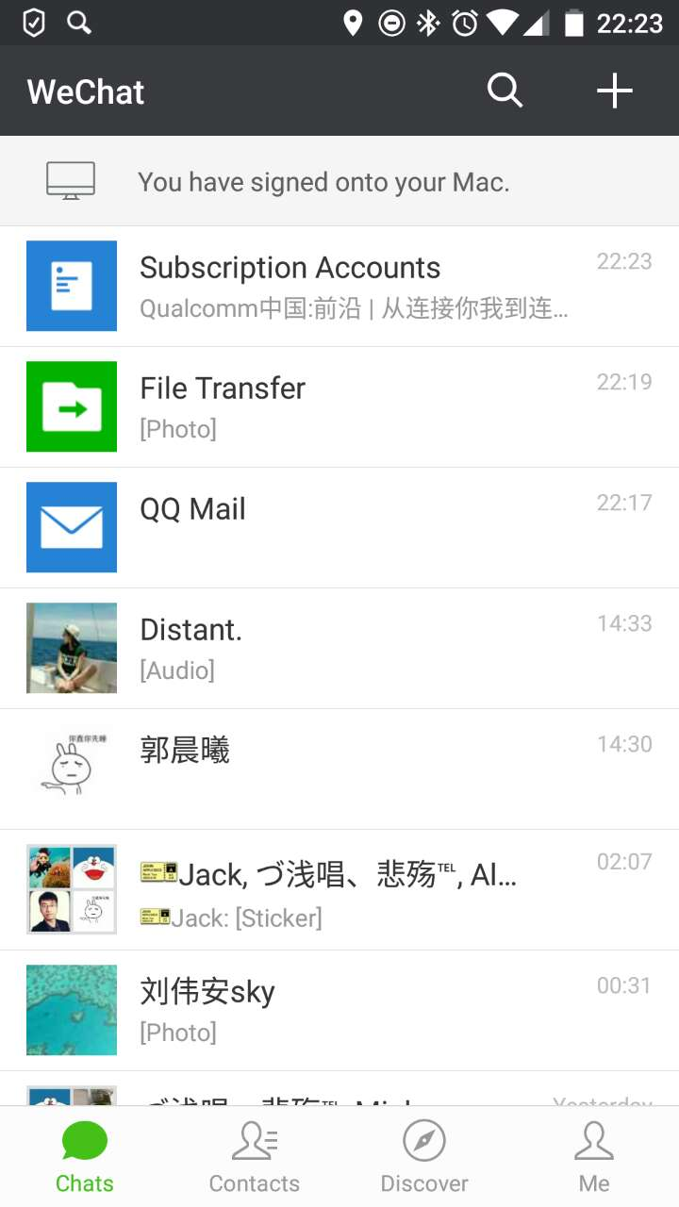 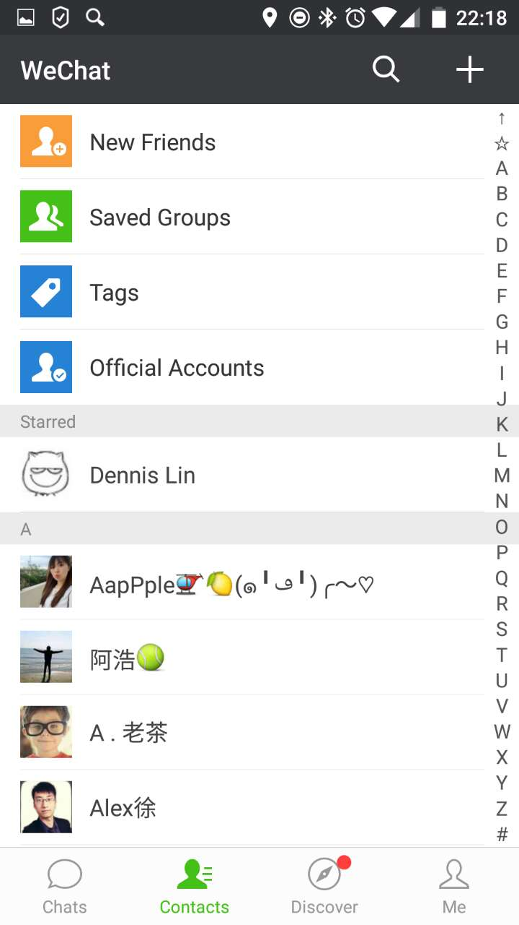 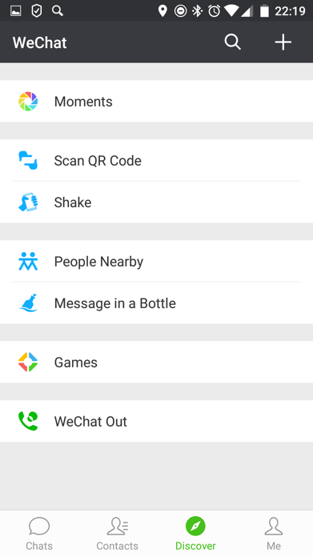

home page contacts page Discover page

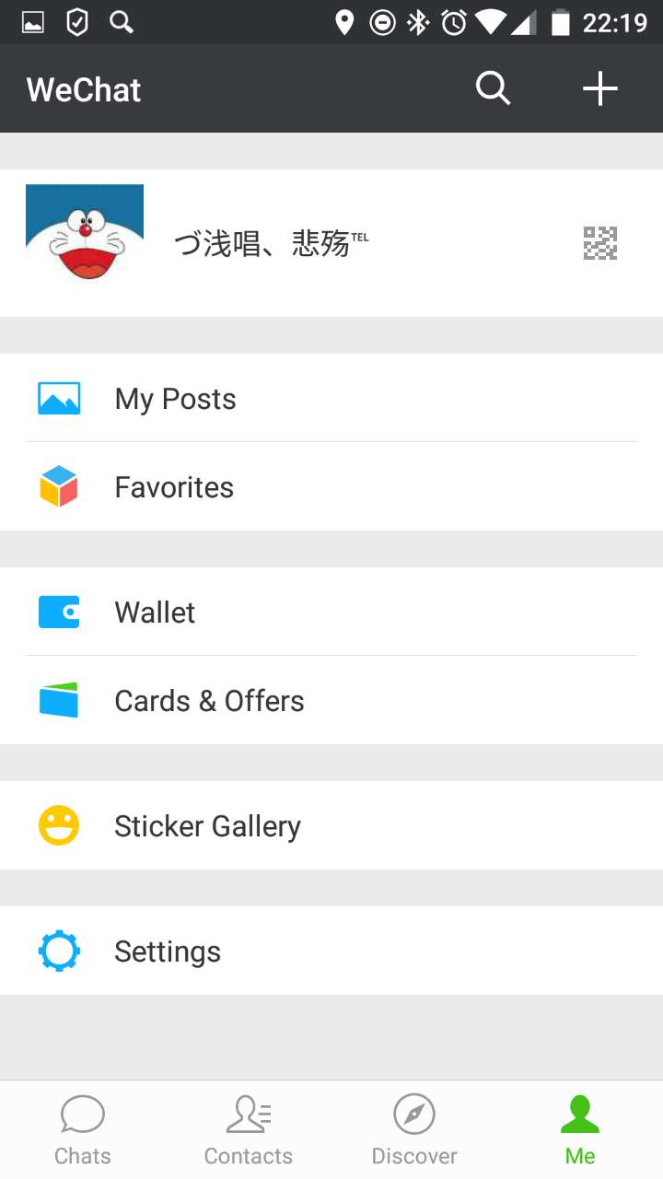 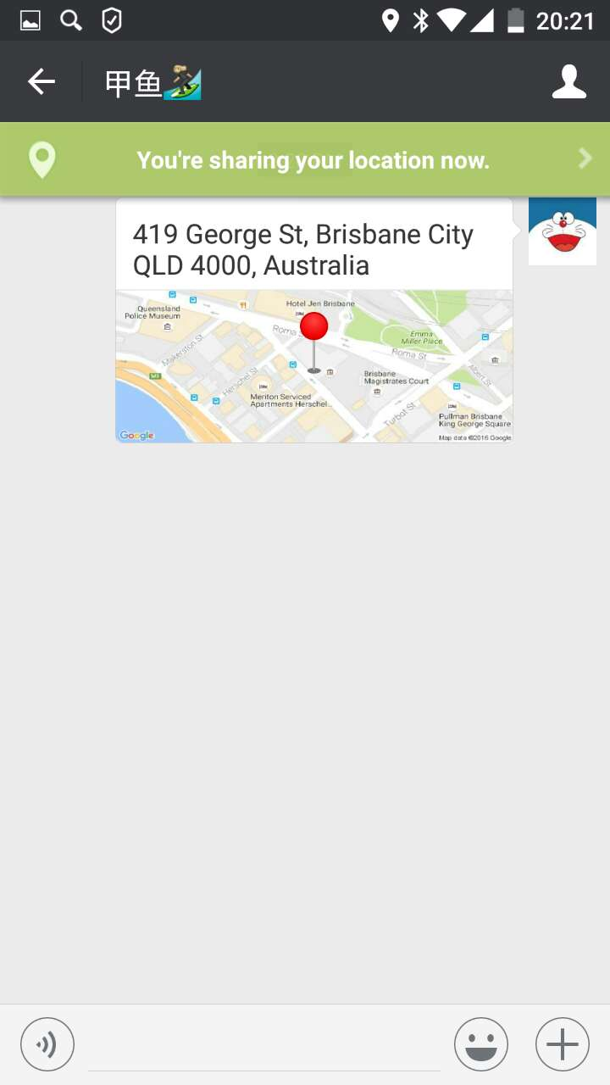 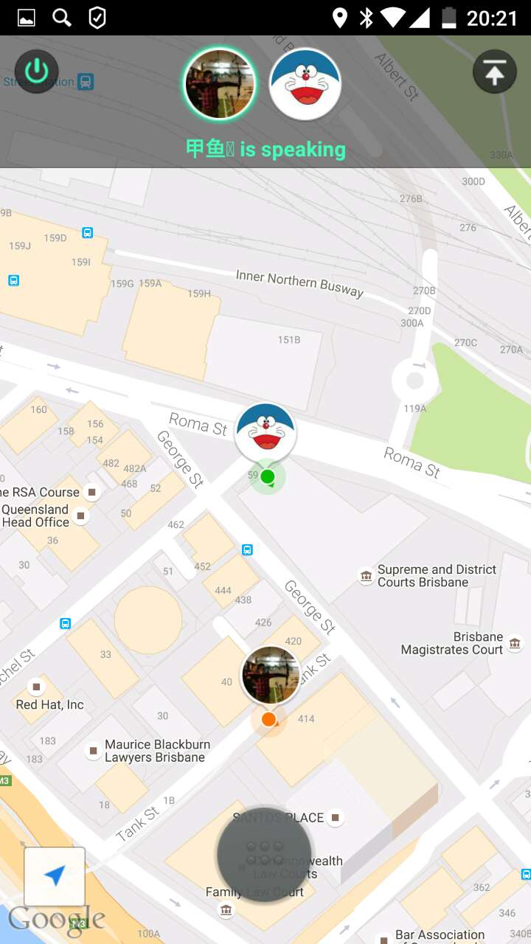

me page sharing location page Real-time location sharing page

**Description:**

WeChat is a messaging and calling app which allows users to easily connect with their families and friends across cities and countries.

**How to use:**

1. Open the app will bring uses to the chat list.
2. There are four main pages – Chats, Contacts, Discover and Me. Users can press the icon on navigation bar to go to these pages.
3. The three main functions of this app are chatting, sharing photos, and sharing locations. Users can chat with friends, share photos to friends and get other people’s location.
4. A notification will remind users that their friends sent messages to them.
5. Users can get one or more peoples’ location by using sharing location function.

**Design & Interactivity**

Advantages:

One of the design principles is easy-to-use. WeChat has a clear and user-friendly interface, which is simple enough that everyone can use it. That’s a very good aspect. When users start to use WeChat, they don’t need to worry about how I can use it or where the function is. Just open the page and find the functions they want. Also, as we all know, the flat design is clean and beautiful and becoming more and more popular in the world. It’s the design tendency. Thus, designers apply this design style to the WeChat and and make it fashionable and beautiful. Moreover, Colors can make a great design. For the WeChat app, there’s no messy feelings when users first see it. Colors are beautiful and comfortable. So, that’s the successful design—clear interface and comfortable UI.

**Features & Functionality**

Advantages: As a communication app, WeChat is an all-in-one communication app for text, voice, video calls and VoIP, as well as some social functions like sharing photos, games, moments and locations. And there are two options in this function. One is “Send Location” and another is “Real-time Location”. For the first one, if you want your friends or families to find you, just send your current location to them, and the message receivers will get your detailed location information and see it on the map. For the second one, it is a highlight function of WeChat and it works differently. When you enable the real-time location sharing in WeChat, you will actually send a location sharing request to your friend so that they can join in the location sharing on mobile phone. Especially, anyone who joined in the real-time location sharing can see other’s location in real-time and meet with friends by navigation system until the location sharing is closed. It’s very convenient to help people find someone using smart phones.

Disadvantages:

When users login WeChat on a new phone or Computer, their message histories will be lost. There is no cloud backup function to storage user’s history or some important information. That is a big problem. And limited retrieval function is another big problem as well. For WeChat, there’s only one way to find the people in contact list—searching by the first letter of the username. Sometimes that’s not convenient. When users want to find a person but forgot his name, it’s hard to find him from large amount of contacts. Searching nearby people is good function, but users can find any other users within 100m. If you decide to find some person you want, WeChat cannot do it. So, that function can be enhanced. It should allow users to find specific people nearby, like friends, colleagues or families.

**Relation to our app:**

The related function with our project is position sharing and communication.

 WeChat – Family Locator

**Google Play URL**: https://play.google.com/store/apps/details?id=com.careu.android

**Screenshots:**

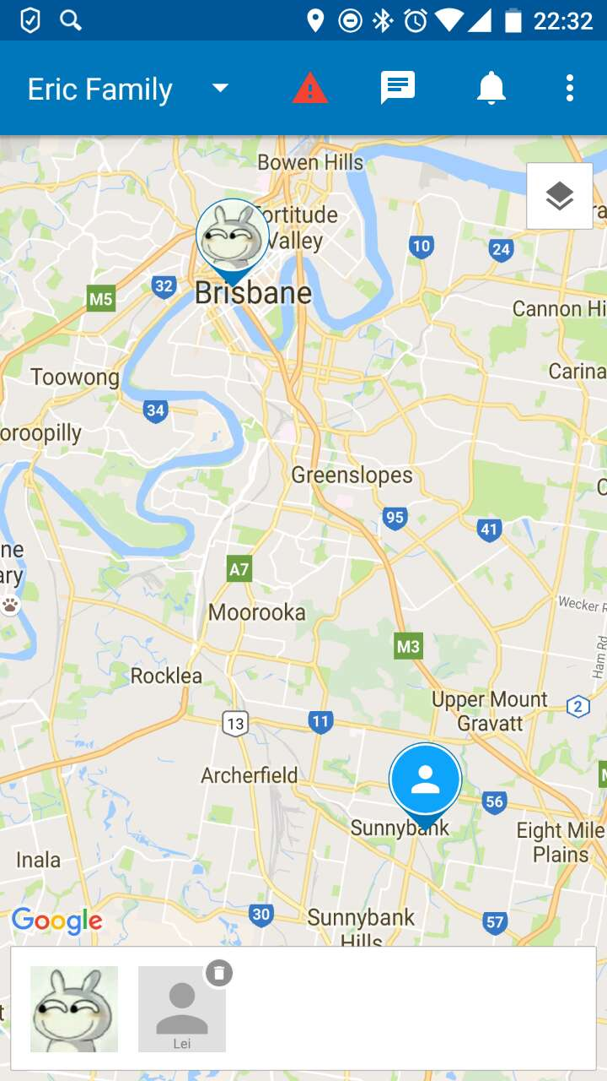 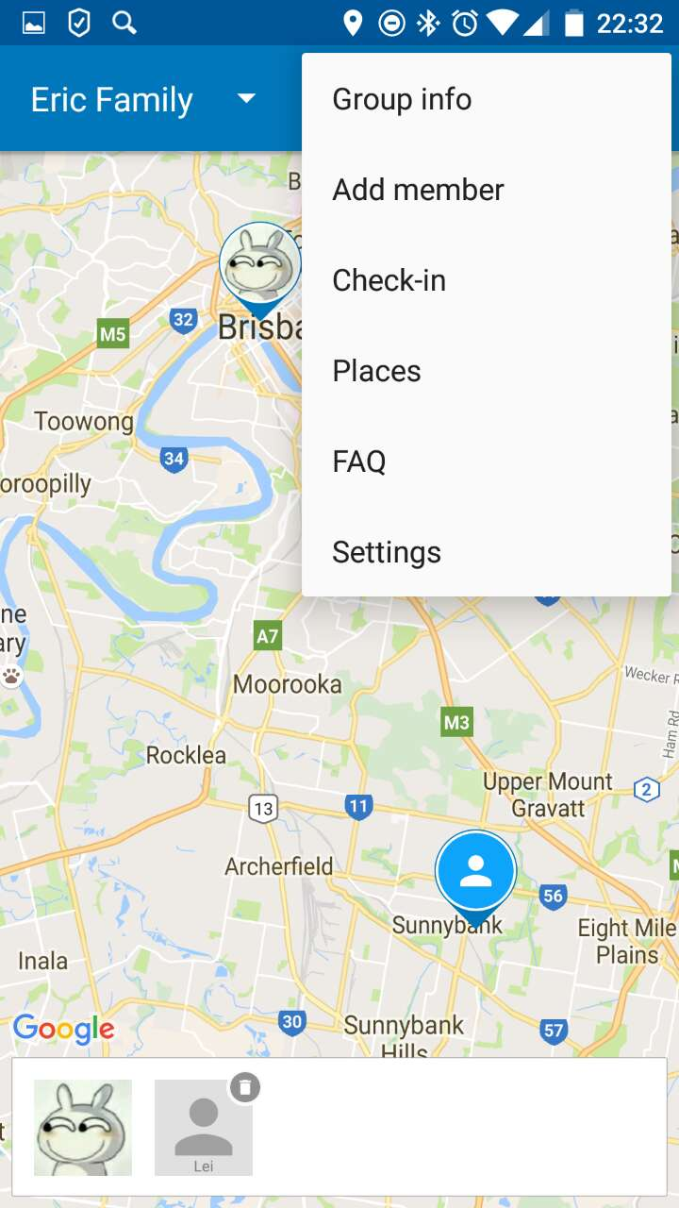 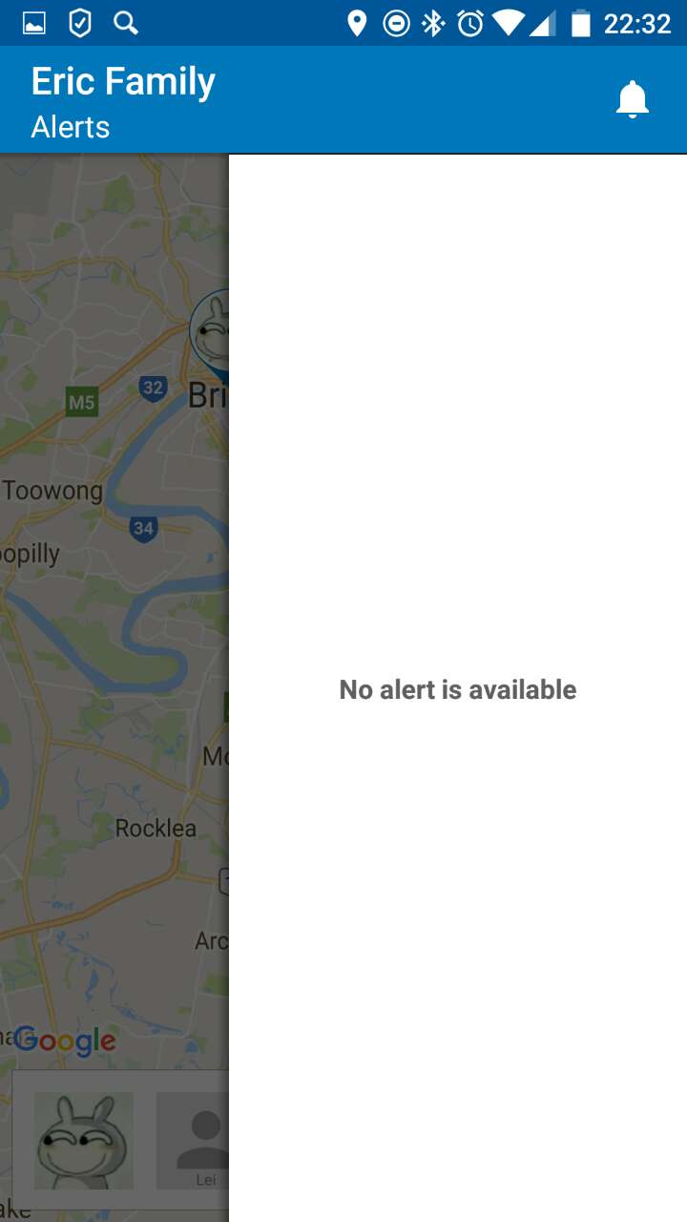

main page menu bar alert bar

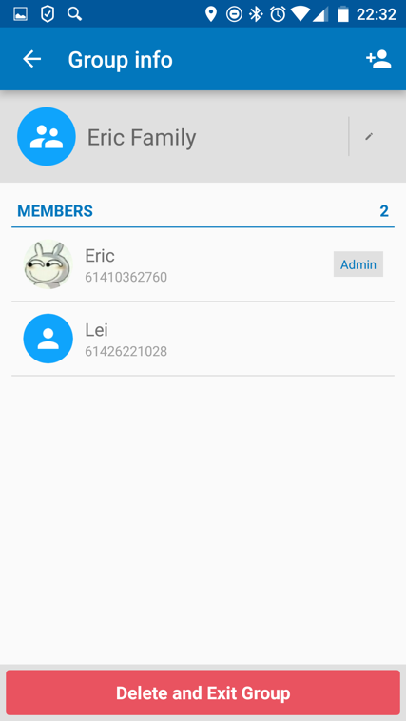 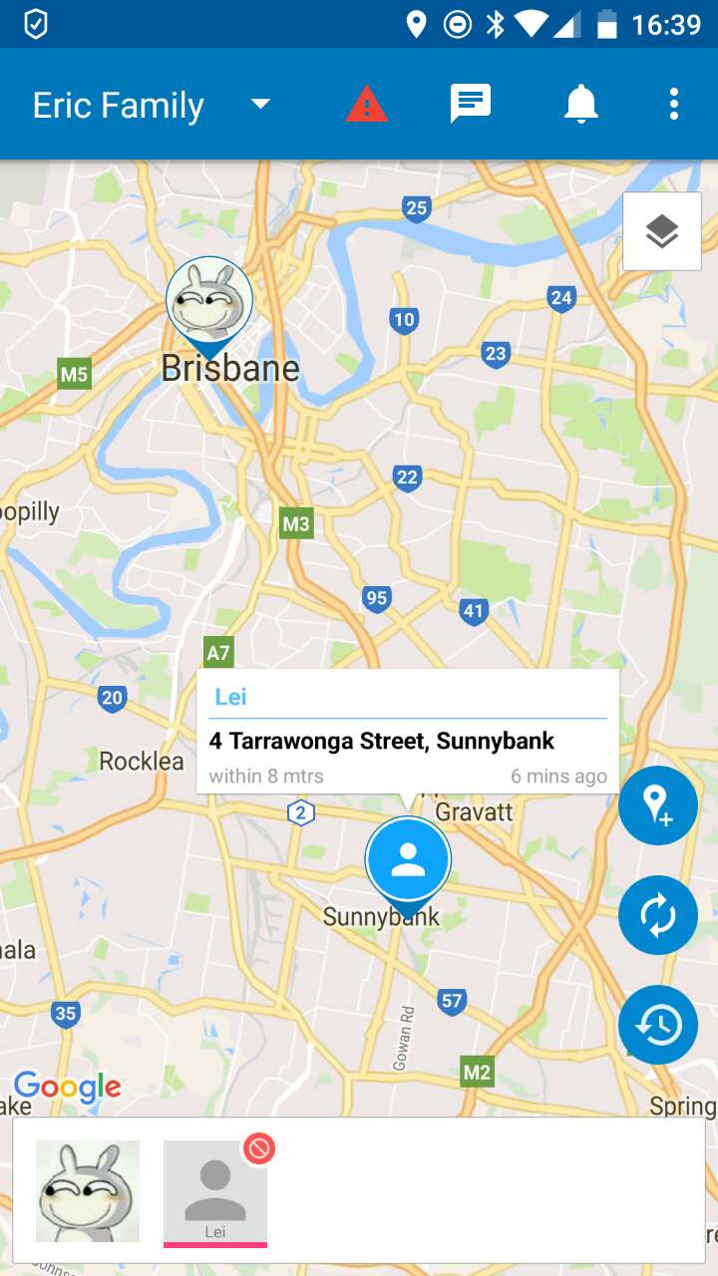 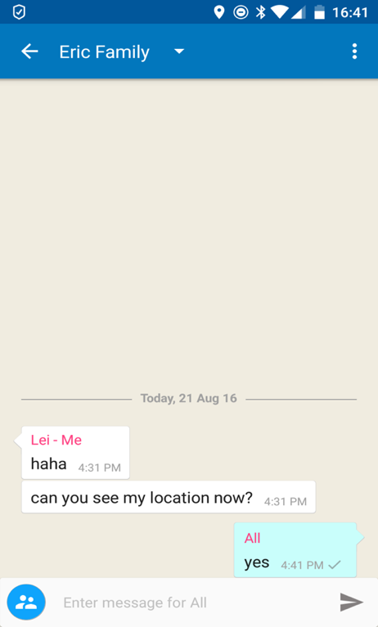

Add member page Share location communication page

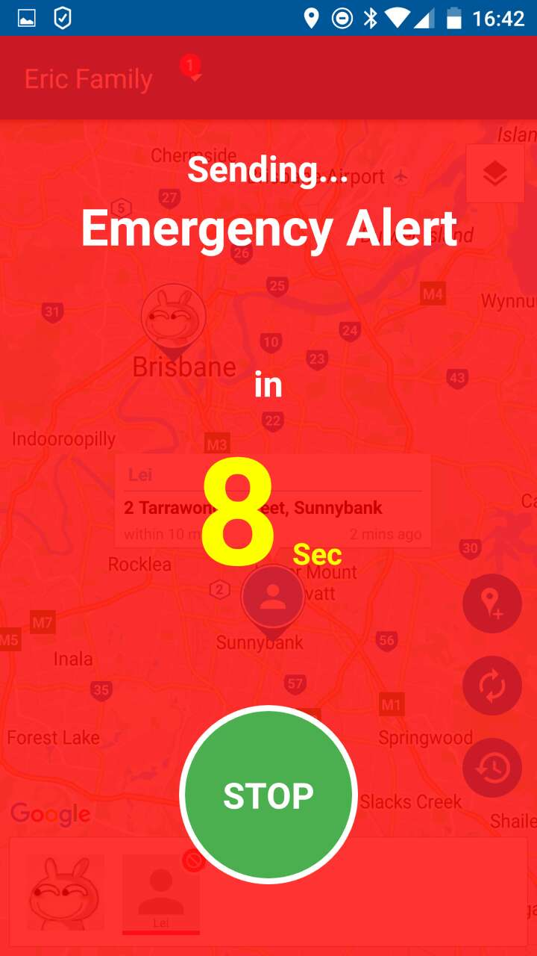

alarming page

**Description:**

CareU is a app which can make you connect always with family members and bring you peace of mind by addressing your daily worries that you have, for the family and others who matter.

**How to use:**

1. Users are asked to verify their phone number and login or register when they first open this app
2. The main page of this app shows a map and marks users current locations
3. Users can add new groups or members by using the “Add member” function on the navigation bar
4. When successfully add a new member, users can see this new member’s location on the map.
5. Users can send messages by pressing “message” button on the navigation bar.
6. To press the red “alarm” button on the navigation bar, your alert message will be sent to others

**Designs & Interactivity:**

Advantages:

CareU has a clear interface which is easy enough for users to use it. There are three parts in this main page—tool bar at the top of the app, a map is in the middle of the screen showing each member’s location information and the photos bar placed at the bottom of the app. That’s a very good aspect, because for this kind of app, most users are focus on where the family members are. So, that’s the reason why designers decided to allocate a big area for the map and put it at the center of the screen. And for family members, they can upload their photos so that everyone can be recognized in the map. that’s a nice design, beautiful and useful. For design, as we all know, the flat design is clean and beautiful and becoming more and more popular in the world. Thus, designers apply this design style to the WeChat and and make it fashionable and beautiful.

**Features & Functionality**

Advantages:

The main function is “get location”. Users can get location and address, in real time, of members of their families and friends groups. In case of an emergency, the user can raise an alert to other group members with his current and complete location details, so that he can get a quick support. If the data is not available, the user can also send alert to others by message. Very useful function for children, women and old people’s safety. And users can also chat with an entire group or an individual online. And for family members, they can upload their photos so that everyone can be recognized in the map.

Disadvantages:

CareU doesn’t have any navigation functions. When one group member needs help, others can see his location on the map, but they cannot use real-time navigation to find a quickest and shortest way to get to the pointed location. Another big problem is that the positioning system is not accuracy sometimes and the orientation errors will happen. For a real example, when one group member sends his location to others two times, the receivers will get two different location details. Maybe this problem will slow the rescue efforts.

**Relation to our app:**

Users can see each group member’s location on the map. If someone want to find the people who are near him, he can see the map to find them. For users, they usually want to set up different groups so that they can find people easily. In this app, users can create different groups, like family group, work group or friend group. And users can add their families, colleagues or friends in these groups. It’s so clear that users can find someone easily and work efficiently. Moreover, emergency function is a nice idea for us. When users need help, they can send alert messages to others to get help. In addition, users should be allowed to communicate with each other. It’s a nice idea for our app. If there’s a meeting, people can talk with others to discuss time and availability.

 Team Locator

**Google Play URL:** <https://play.google.com/store/apps/details?id=com.tonikorin.team_locator>

**Screenshots:**

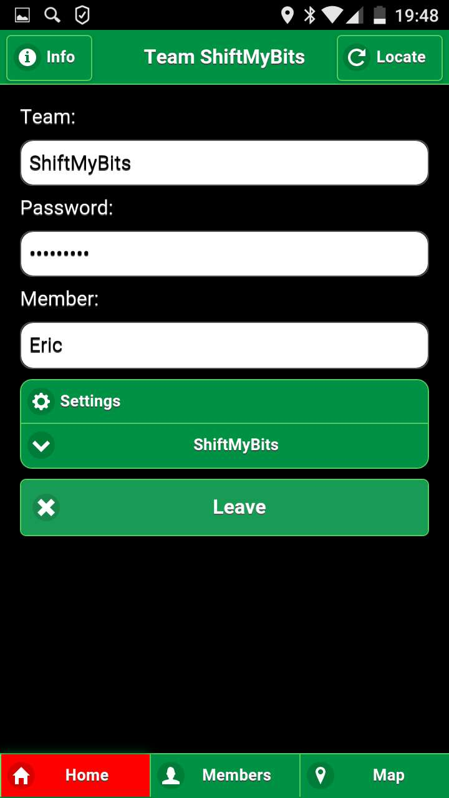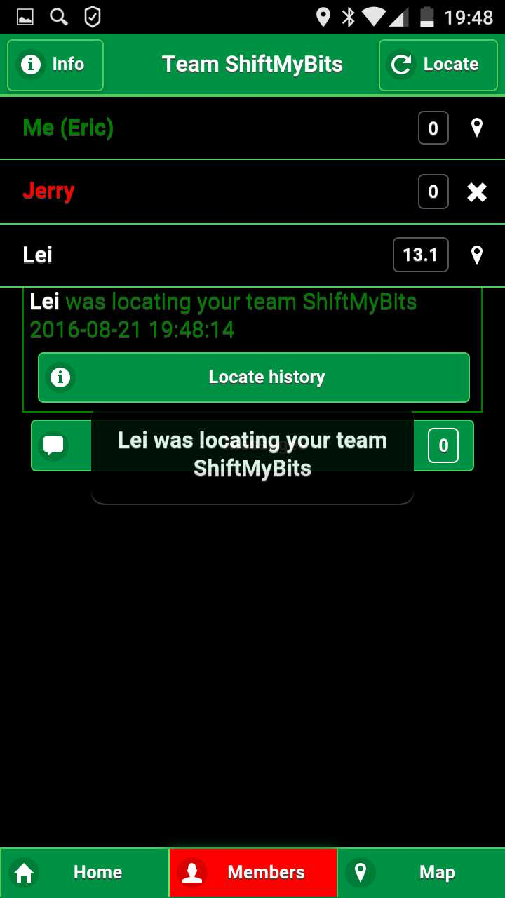 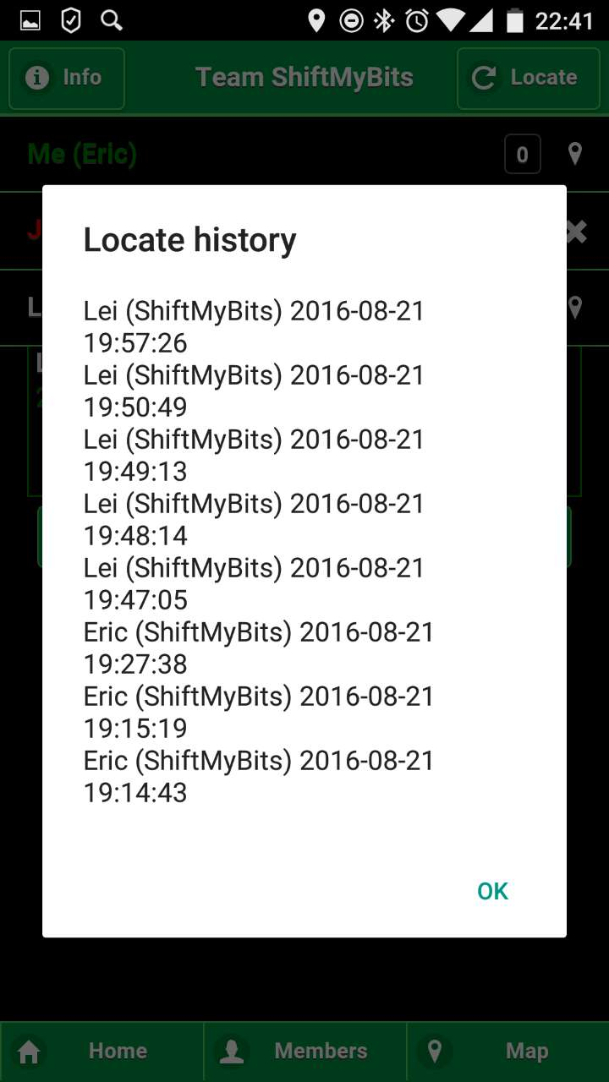

Home page member page locate history page

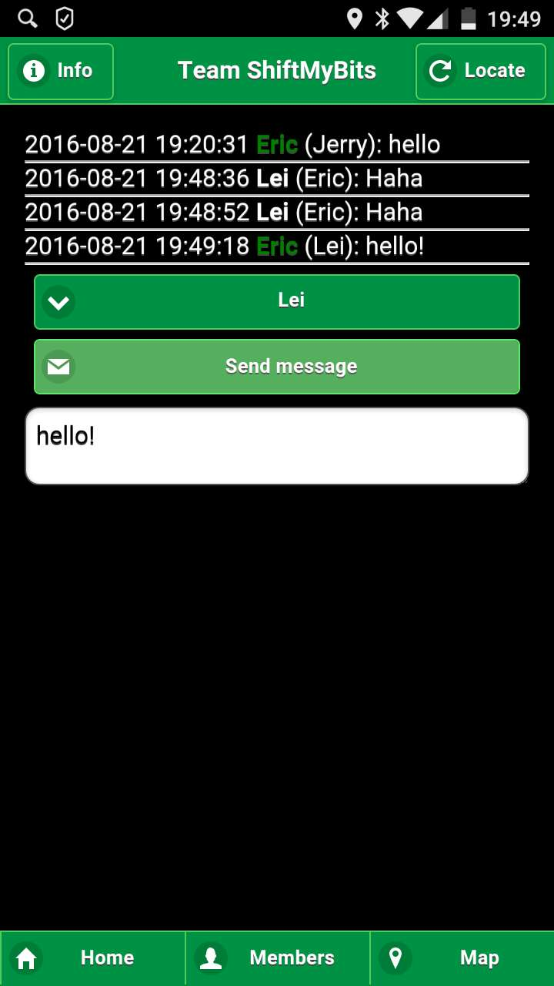 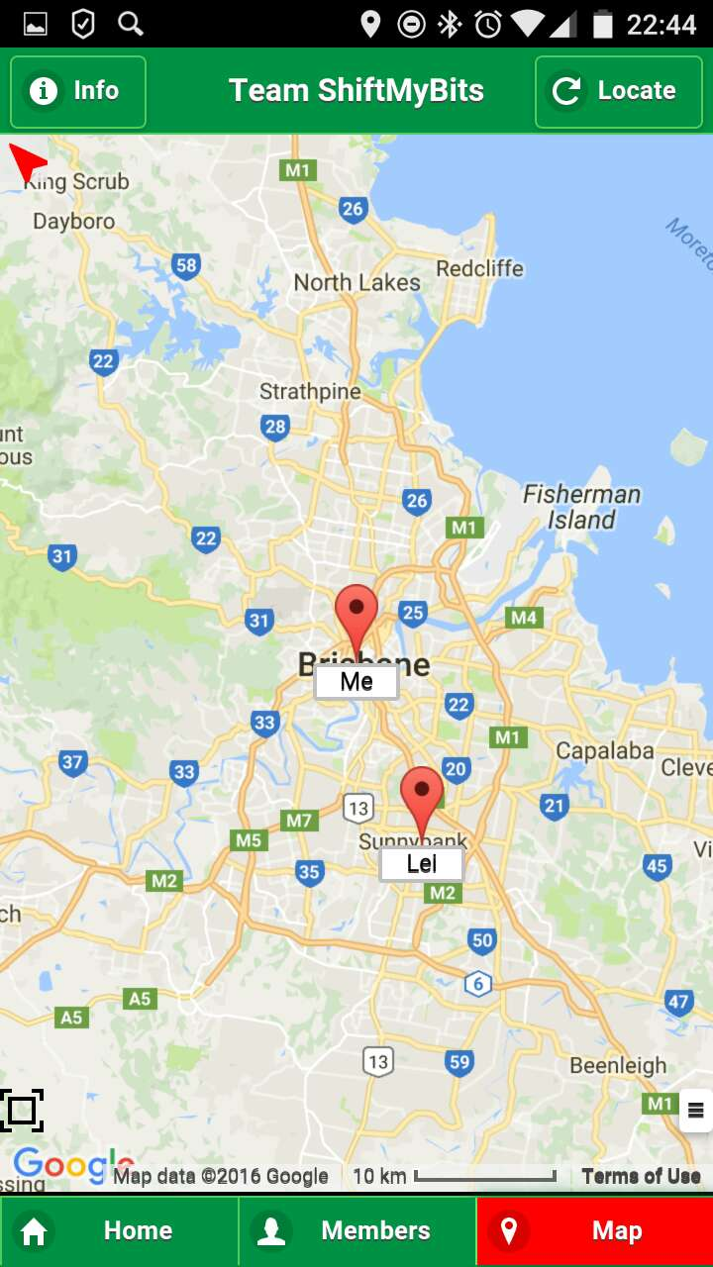

communication page map page

**Description:** Team locator is used to locate any kind of team members. Each team member can send messages to others and find detailed locations on the map.

**How to use:**

1. Launching the app will show the “Home” page. And users are allowed to create a team, team’s password and a member in that page.
2. When create successfully, you can see your name in “member” page and current location in “Map” page.
3. Users can input team’s name, password and their names in the “home” page to join in this team.
4. Team members can chat with each other by using “messages” function in the “members” page.
5. Each team member can see others’ locations in the map in “map” page.

**Designs & Interactivity:**

Advantages:

Team Locator has a clear interface which is easy enough for users to use it. There are three buttons at the bottom of the app—Home, Member and Map. That’s a very good aspect, because most users are focus on chatting with other teams and find their location. So, clear interface and practicality are most important.

Disadvantages:

The fatal weakness is ugly interface---Green and Black are the main colors of this app. Obviously, it’s not beautiful, especially by comparing with other apps. Also, the UI is too simple.

**Features & Functionality:**

Advantages:

And one of the core functions is location sharing. People can get others’ location information and see theirs’ position on the map by using this app. Importantly, the location data is not stored to any external servers, so the location information is just shared between team members. For a team, it’s easy to join in a team. When administer creates a team, other team members can join in this team by inputting the team’ s name, password and their names. For team members, sometimes they want to see each other’s status information. For example, one team member’s mobile phone cannot provide positive information, then the app will highlight this team member and show an error or warning icon. So, it is easy to check status in the app. And team members can chat with others online as well. Furthermore, leaving uses can save team details for later use.

Disadvantages:

Team locator doesn’t have any navigation functions. When one group member needs help or want to find someone, others can see his location on the map, but they cannot use real-time navigation to find a quickest and shortest way to get to the pointed location.

**Relation to our app:**

Show positions: Users can see group members’ locations on the map. If someone want to find the people who are near him, he can see the map to find them. When users get others’ location, maybe they want to chat with these people. So, users should be allowed to communicate with each other. It’s a nice idea for our app. If there’s a meeting, people can talk with others to discuss time and availability. And the design principal should be easy-to-use. This app provides the inspiration about how to design an easy-to-use app for users. Our app’s interface should be clear and the app shouldn’t have some redundant functions, just focus on team communication and location sharing.